Key Management Service & Secret Manager Task

Overall Task Objective:
- To implement secure data protection and credential management using AWS security services.
- To understand and apply encryption at rest using AWS KMS.
- To secure Amazon S3 objects using SSE-S3 and SSE-KMS.
- To manage IAM permissions and validate access control with encrypted resources.
- To create and manage database credentials securely using AWS Secrets Manager.
- To integrate Amazon RDS with Secrets Manager for automatic credential storage and rotation.
- To use AWS CLI for secret creation and validate region consistency.
- To gain hands-on experience with AWS security best practices.
Overall Task Prerequisites:
- Active AWS account
- Basic understanding of AWS services:
  - AWS KMS
  - Amazon S3
  - AWS IAM
  - Amazon RDS
  - AWS Secrets Manager
- IAM user with permissions to:
  - Create and manage KMS keys
  - Manage S3 buckets and encryption
  - Create and manage Secrets Manager secrets
  - Create and manage RDS databases
- AWS CLI installed and configured
- Valid AWS Access Key and Secret Access Key
- Knowledge of AWS regions and encryption concepts

Task Title
Implement Secure Data Encryption in Amazon S3 using AWS KMS and Access Control Validation
Objective
- To create and manage a customer-managed encryption key using AWS KMS.
- To configure Amazon S3 bucket encryption using SSE-KMS.
- To upload and store objects securely in an encrypted S3 bucket.
- To validate access permissions for encrypted S3 objects.
- To understand how IAM and KMS permissions work together for secure data access.

Prerequisites
- Active AWS account
- Basic understanding of AWS services:
  - Amazon S3
  - AWS KMS
  - AWS IAM
- IAM permissions to:
  - Create and manage KMS keys
  - Create and manage S3 buckets
  - Attach IAM policies to users
- Access to AWS Management Console
- Knowledge of server-side encryption concepts
Steps Performed
S3 Bucket Creation
- Navigated to Amazon S3 → Buckets → Create bucket.
- Selected AWS Region: US East (N. Virginia – us-east-1).
- Chose Bucket type: General purpose.
- Entered bucket name as taskkms.
- Left Object Ownership as ACLs disabled (Bucket owner enforced).
- Did not add any bucket tags.
- Enabled Default encryption.
- Selected Server-side encryption with Amazon S3 managed keys (SSE-S3).
- Enabled Bucket Key to reduce encryption costs.
- Reviewed configuration and created the S3 bucket.
Verifying Object Encryption
- Opened index.html object details.
- Checked Storage class section showing Standard.
- Checked Server-side encryption settings showing SSE-S3 enabled.
- Confirmed data is encrypted at rest using Amazon S3 managed keys.

IAM User Creation for S3 Access
- Navigated to IAM → Users → Create user.
- Entered IAM username as testkms.
- Proceeded to Set permissions.
- Selected Attach policies directly.
- Searched for S3 policies.
- Attached AmazonS3FullAccess managed policy.
- Skipped adding tags.
- Reviewed configuration and created the IAM user.
- Verified success message showing User created successfully.
- Confirmed testkms appears in the IAM users list.

Access Validation
- Confirmed IAM user has AmazonS3FullAccess policy attached.
- Verified the IAM user can access S3 resources.
- Ensured uploaded object remains encrypted using SSE-S3.

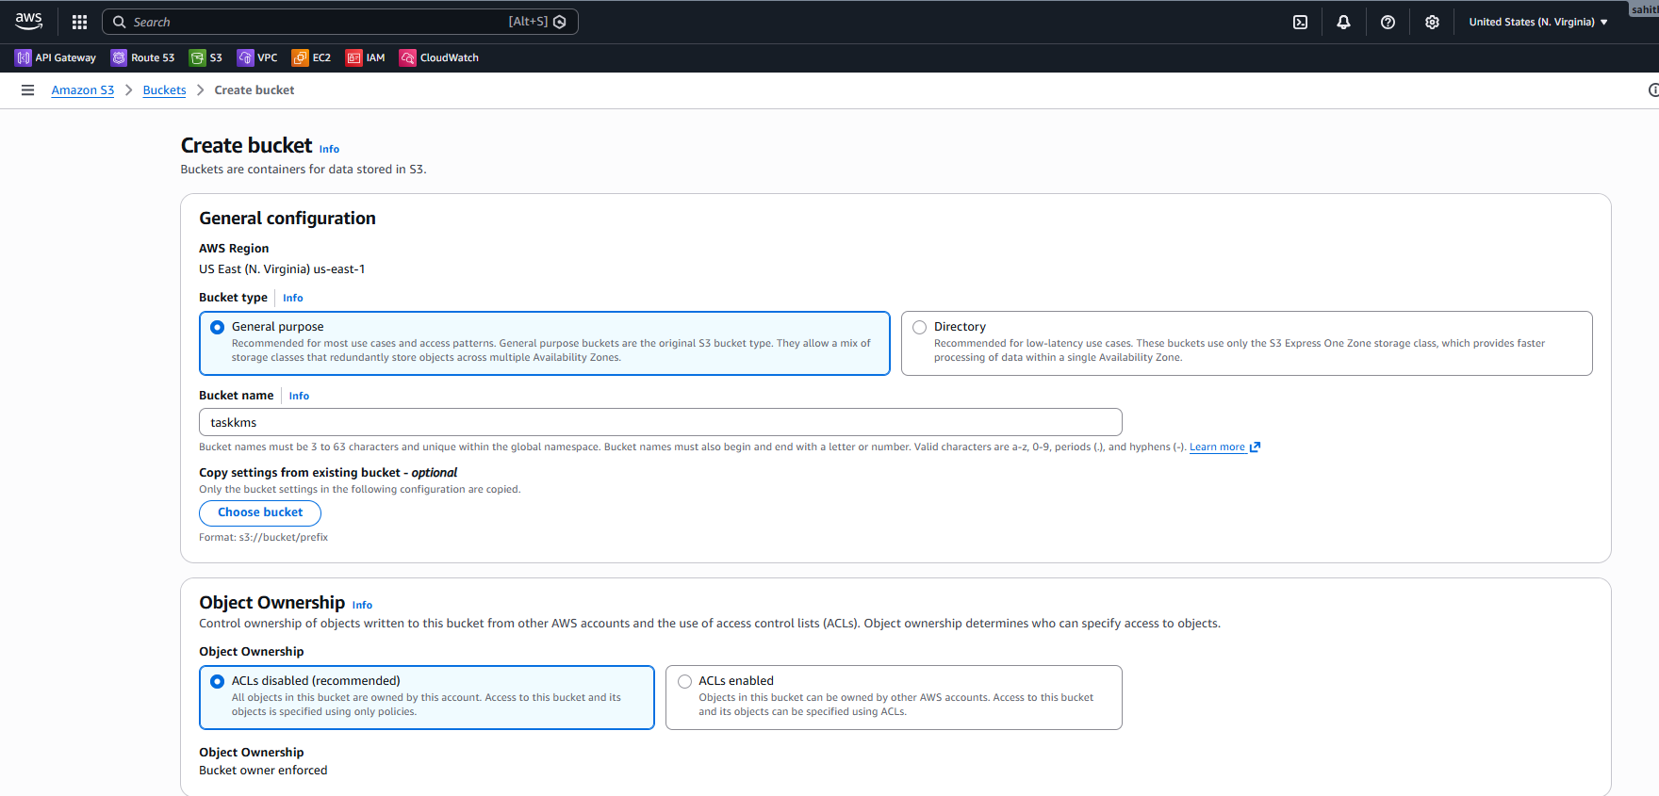
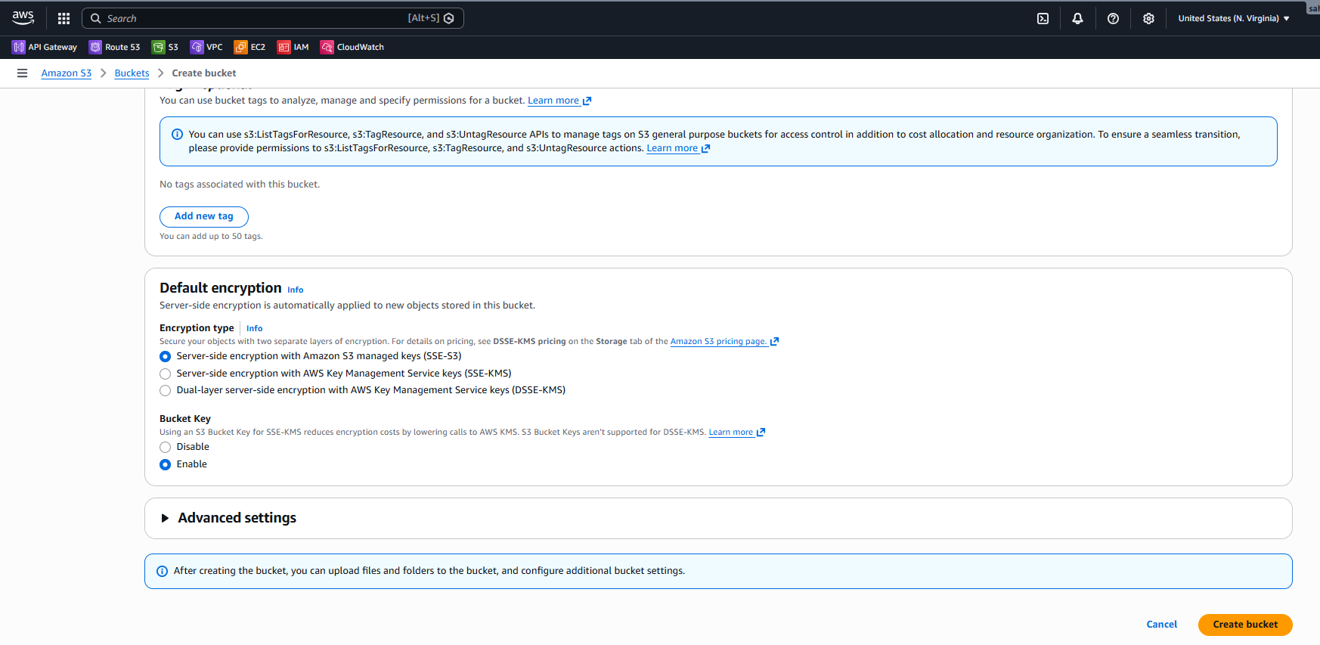
Uploading Object to S3 Bucket
- Opened the newly created bucket taskkms.
- Used the Upload option to add a file.
- Uploaded index.html to the bucket.
- Verified the object is listed inside the bucket.
- Confirmed object storage class is Standard.
- Verified server-side encryption is enabled using SSE-S3.

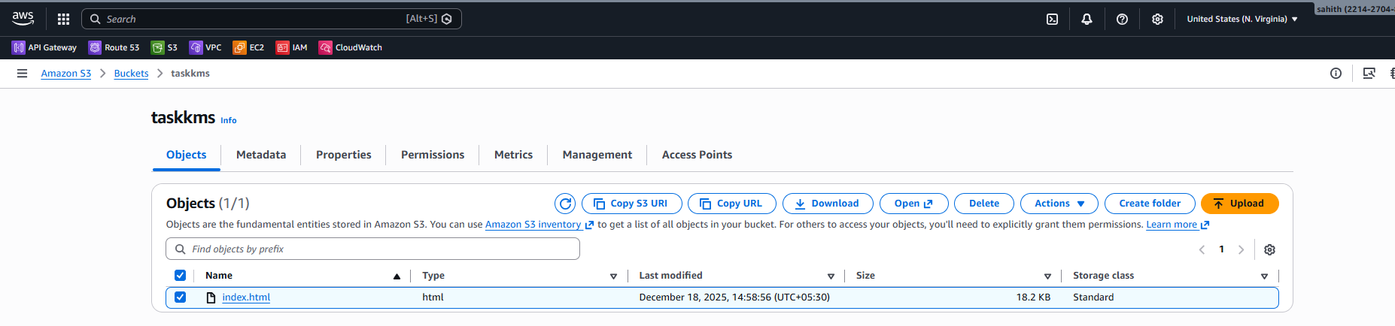
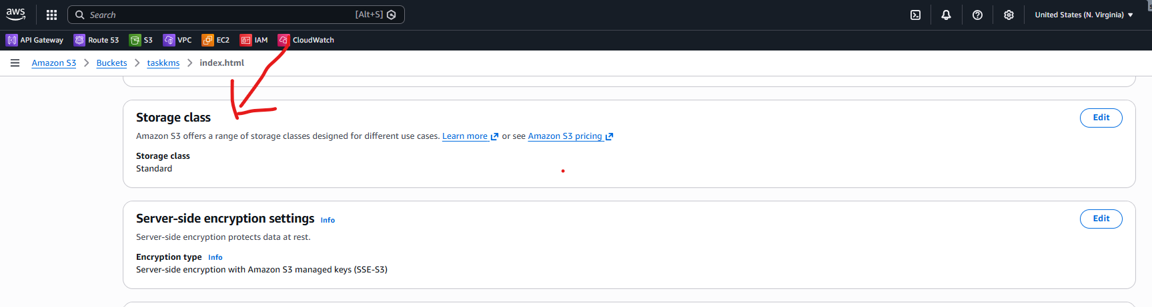
Verifying Object Encryption
- Opened index.html object details.
- Checked Storage class section showing Standard.
- Checked Server-side encryption settings showing SSE-S3 enabled.
- Confirmed data is encrypted at rest using Amazon S3 managed keys.

IAM User Creation for S3 Access
- Navigated to IAM → Users → Create user.
- Entered IAM username as testkms.
- Proceeded to Set permissions.
- Selected Attach policies directly.
- Searched for S3 policies.
- Attached AmazonS3FullAccess managed policy.
- Skipped adding tags.
- Reviewed configuration and created the IAM user.
- Verified success message showing User created successfully.
- Confirmed testkms appears in the IAM users list.
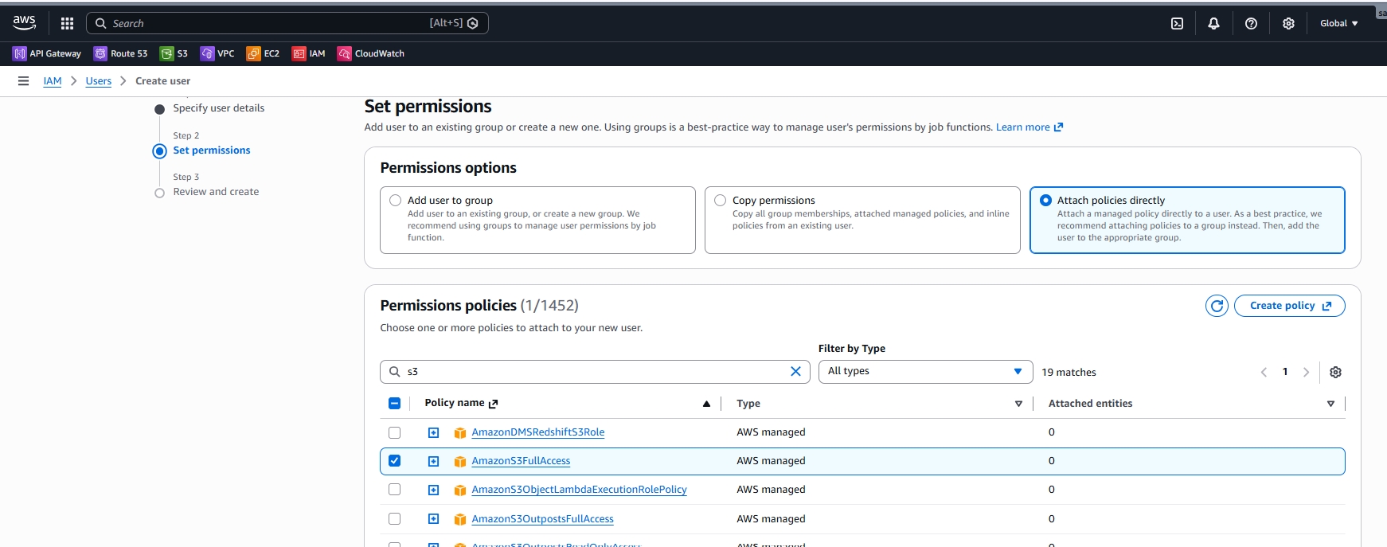
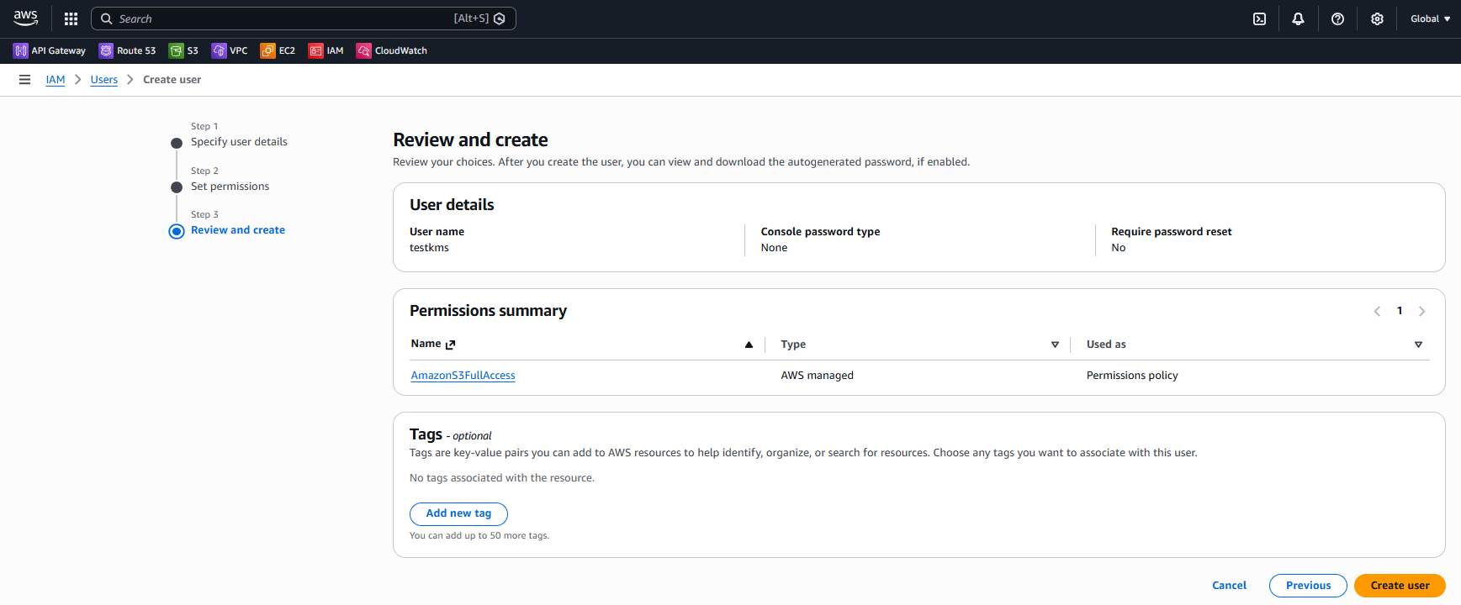
Access Validation
- Confirmed IAM user has AmazonS3FullAccess policy attached.
- Verified the IAM user can access S3 resources.
- Ensured uploaded object remains encrypted using SSE-S3.

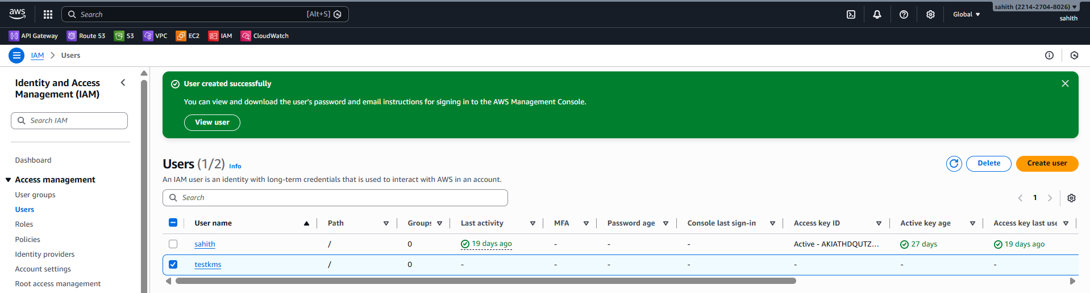Steps Performed
S3 Bucket – Object Verification
- Opened Amazon S3 → Buckets → taskkms.
- Viewed Objects tab.
- Verified index.html file is present in the bucket.

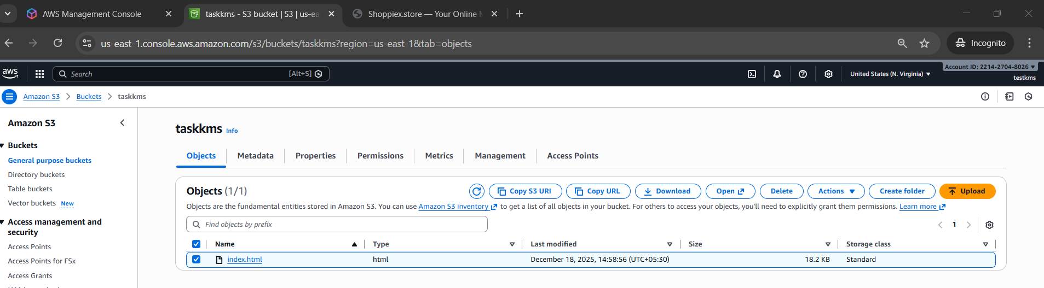
KMS Key Creation
- Navigated to KMS → Customer managed keys → Create key.
- Selected Key type: Symmetric.
- Selected Key usage: Encrypt and decrypt.
- Kept Key material origin: KMS (recommended).
- Selected Single-Region key.
- Proceeded to next step.
- Skipped adding other AWS accounts.
- Reviewed and created the KMS key.
- Verified KMS key created successfully.
- Confirmed key status is Enabled.
- Confirmed key type is Symmetric with Encrypt and decrypt usage.
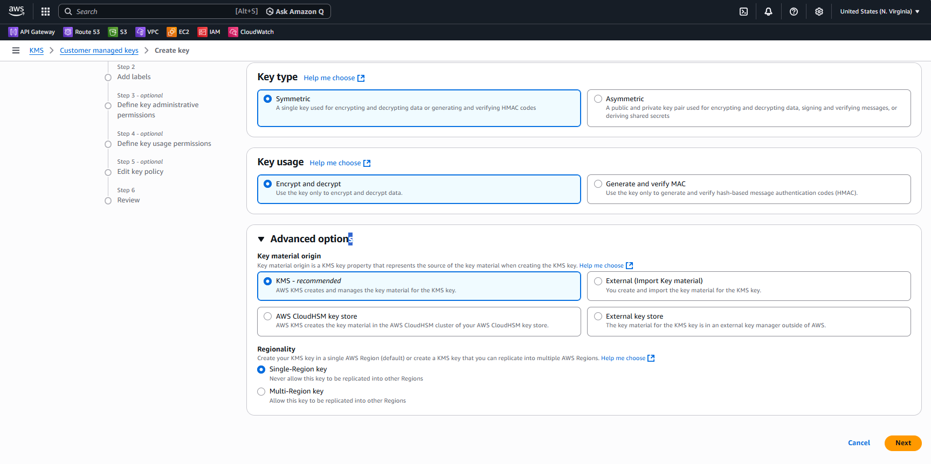
- Added Alias name: Test-kms.
- Skipped description.
- Skipped tags.
- Selected Key administrators.
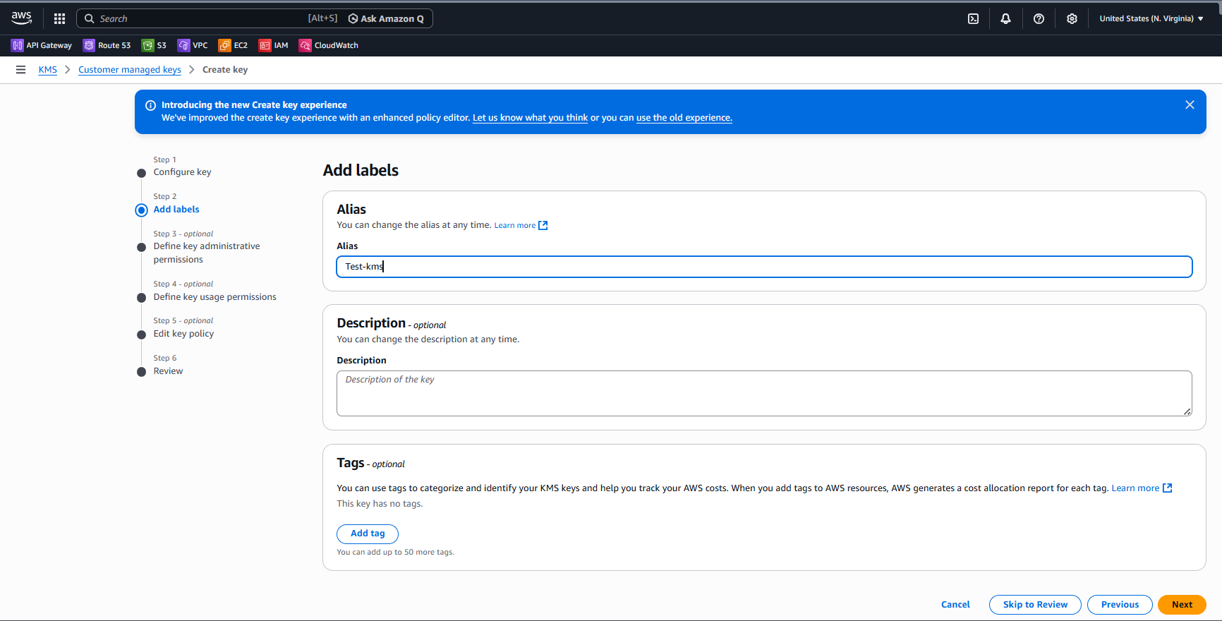
- Chose testkms IAM user as key administrator.
- Enabled option to allow key administrators to delete this key.
- Selected Key users.
- Chose testkms IAM user as key user.
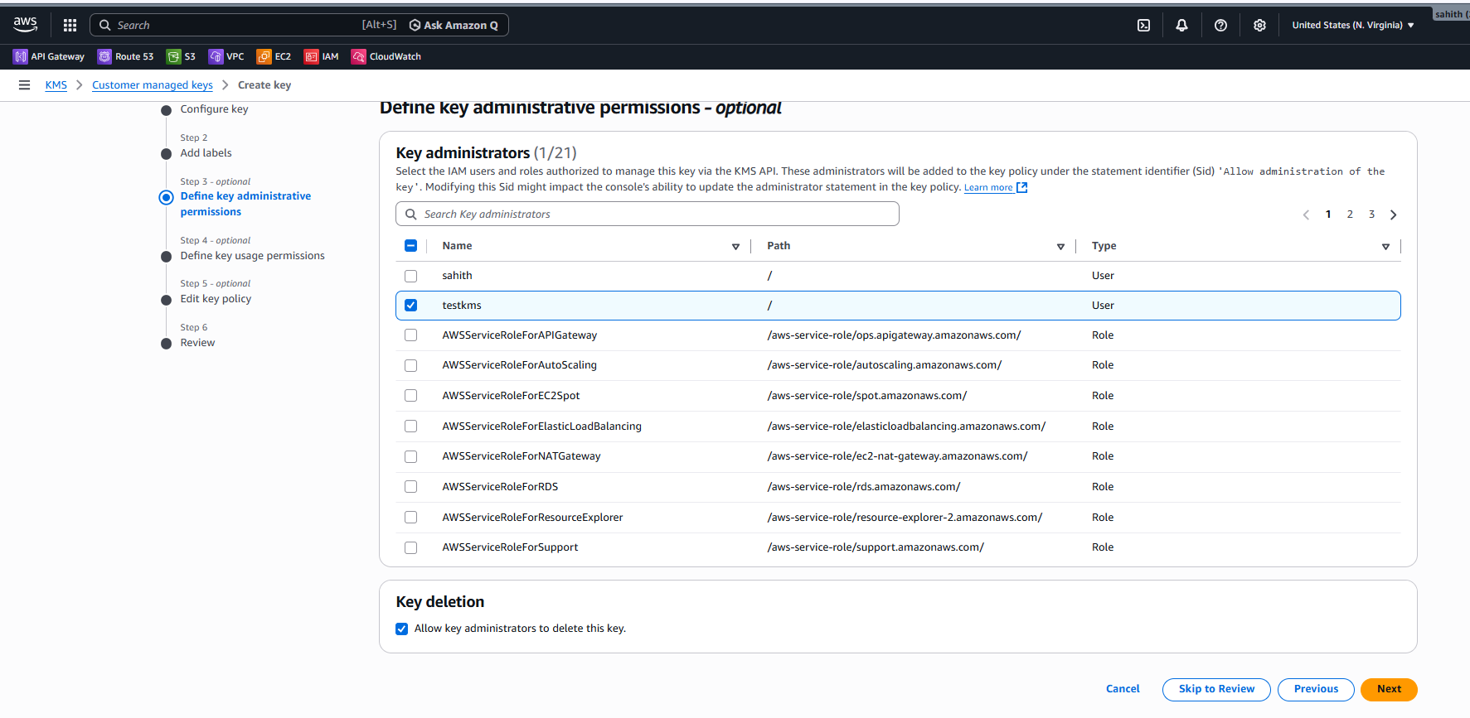
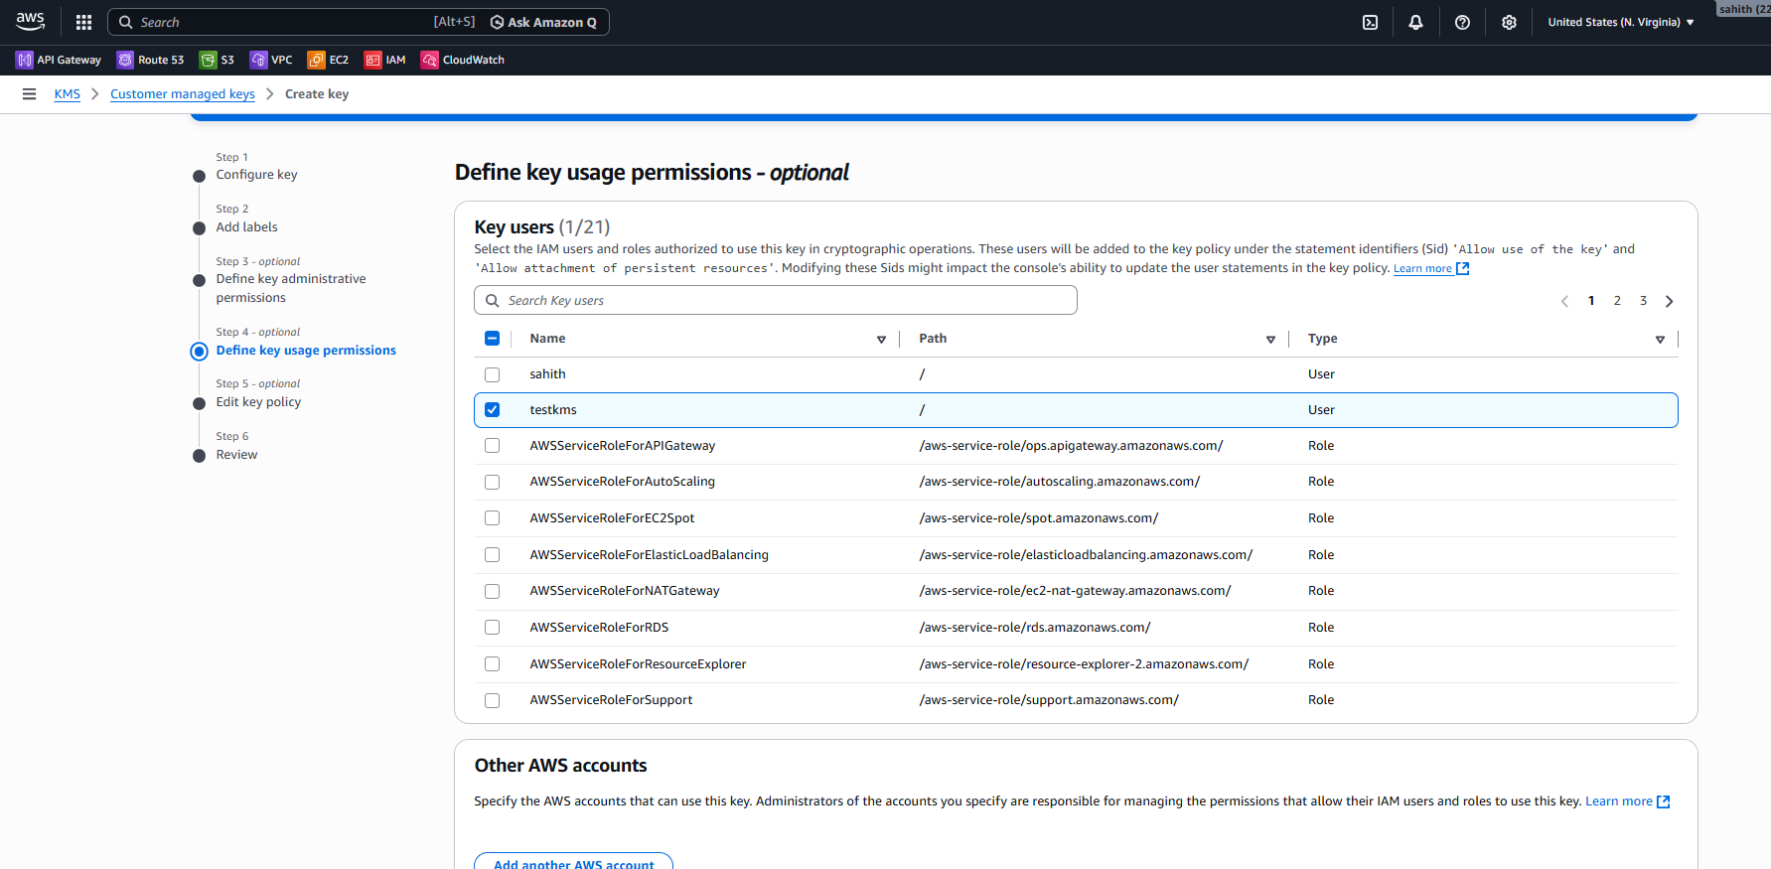
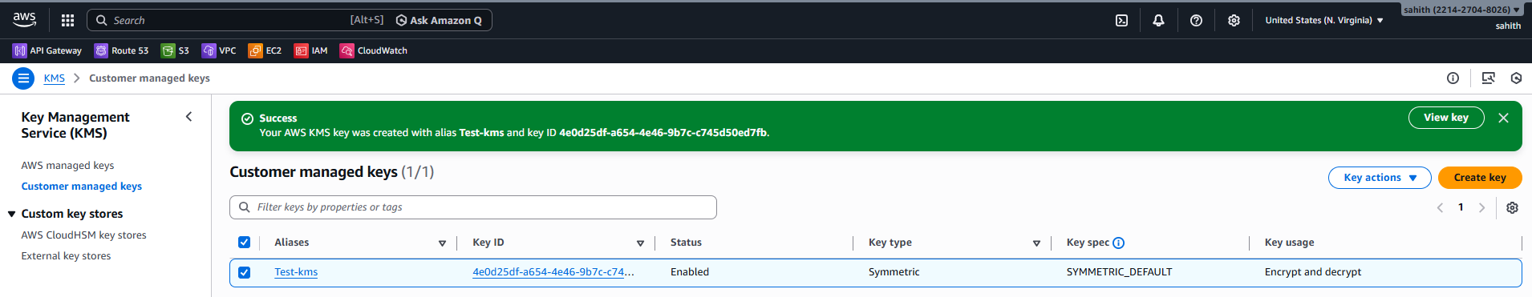
Update S3 Bucket Encryption to SSE-KMS
- Navigated to Amazon S3 → Buckets → taskkms.
- Opened Properties tab.
- Clicked Edit under Default encryption
- Selected Override bucket settings for default encryption.
- Selected Server-side encryption with AWS KMS keys (SSE-KMS).
- Chose AWS KMS key from available keys.
- Selected Test-kms key.
- Enabled Bucket Key.
- Saved changes.
- Verified Default encryption updated successfully.
- Confirmed Encryption type: SSE-KMS.
- Confirmed KMS key ARN is attached.
- Confirmed Bucket Key: Enabled

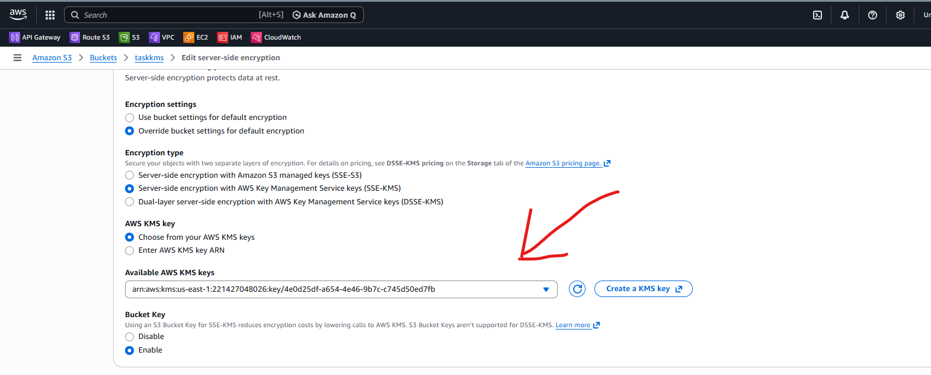
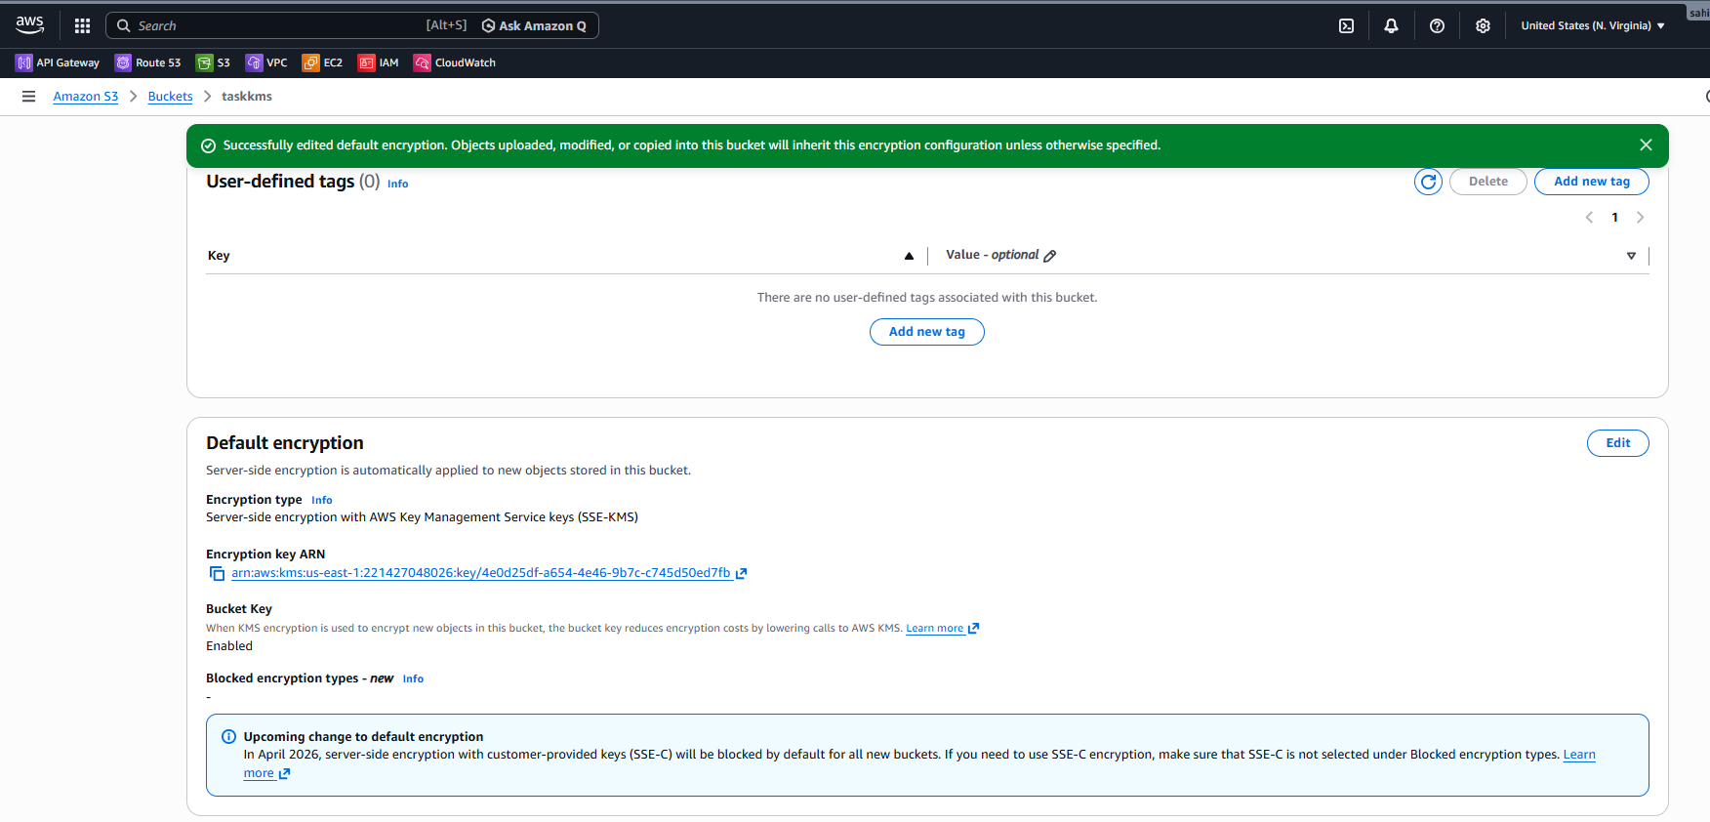
Upload File with KMS Encryption
- Opened taskkms bucket.
- Clicked Upload.
- Added file shop-listing.html.
- Verified destination as s3://taskkms.
- Kept default permissions and properties.
- Clicked Upload.
- Verified Upload succeeded.
- Confirmed file status shows Succeeded.
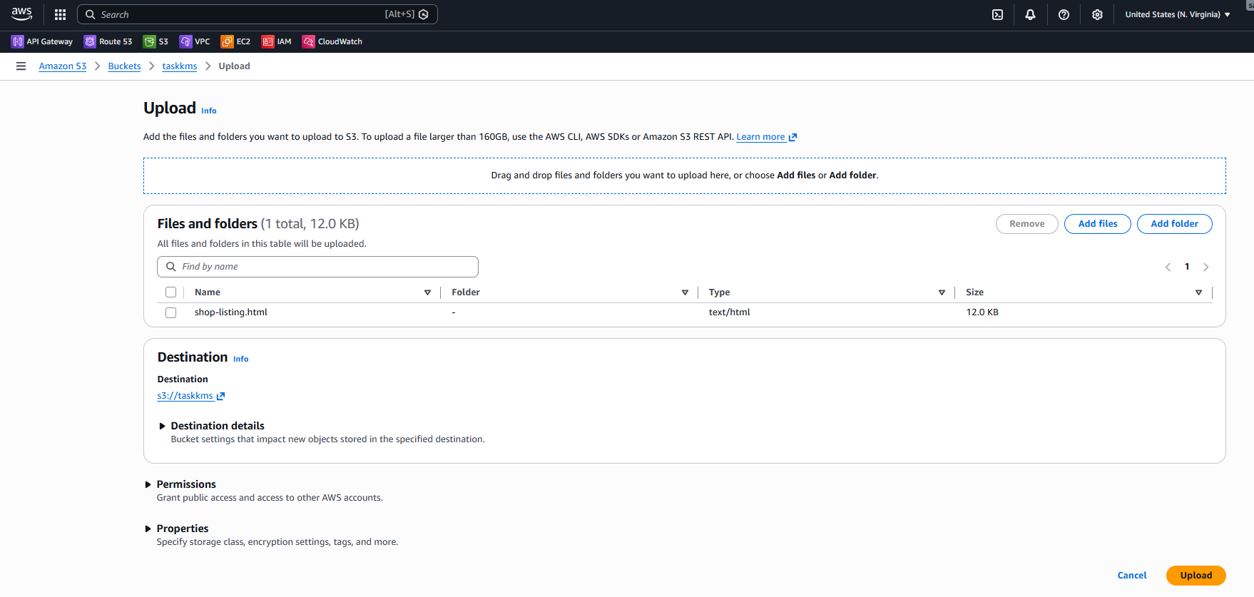
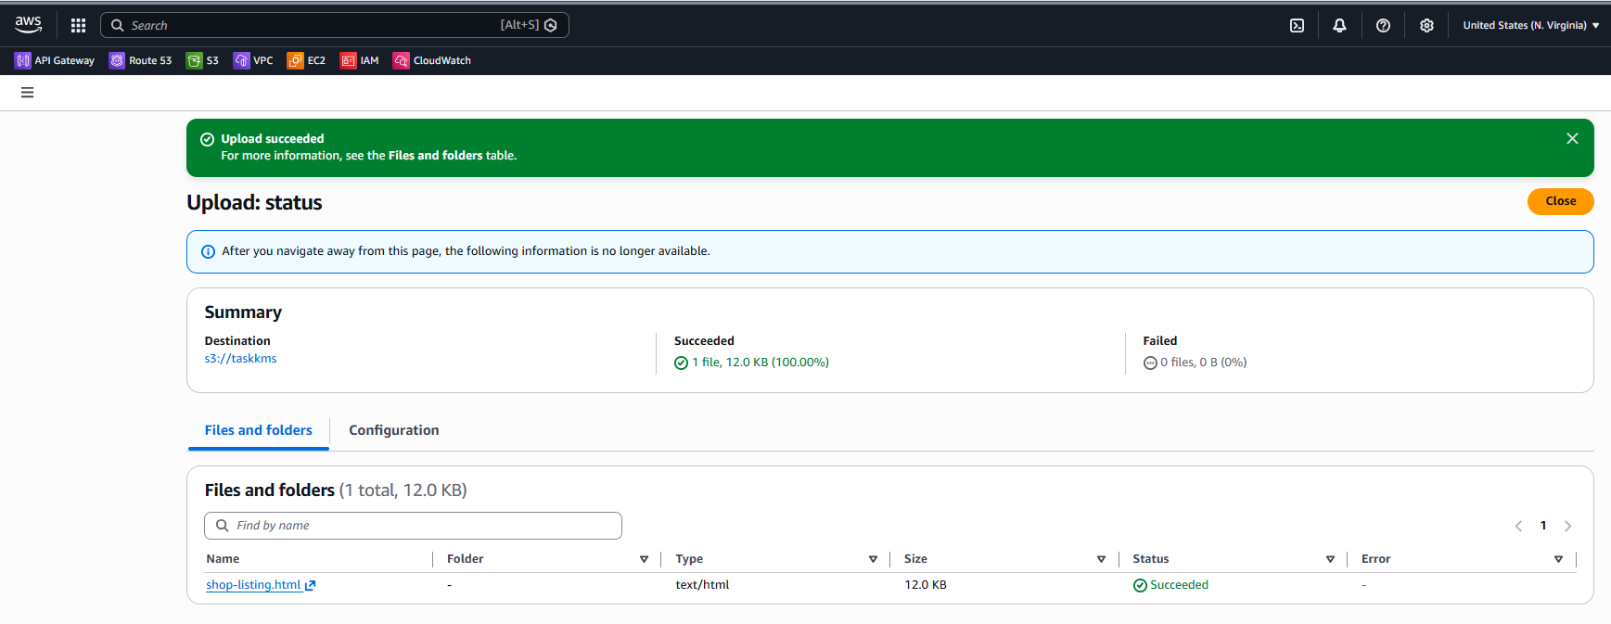
- Opened IAM → Users → sahith.
- Viewed Permissions tab.
- Verified AmazonEC2FullAccess policy attached.
- Verified AmazonS3FullAccess policy attached.
- Confirmed policies are attached directly to the user.

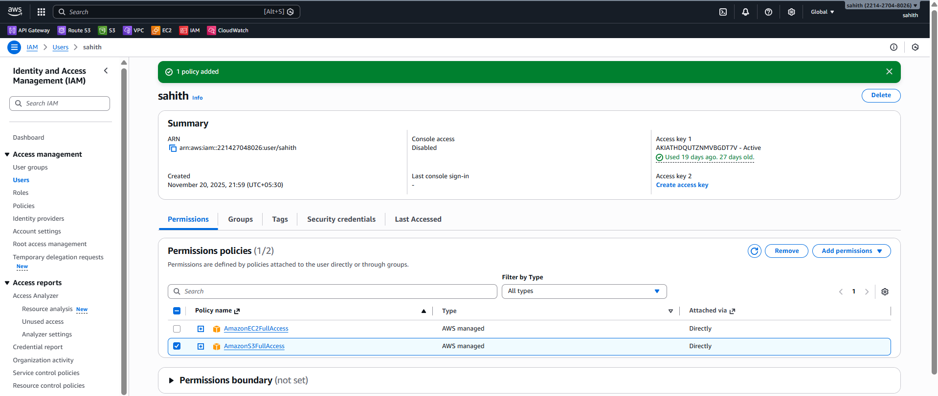
- Navigated to Amazon S3 → Buckets → taskkms.
- Opened Objects tab.
- Verified index.html object exists.
- Verified shop-listing.html object exists.
- Confirmed both objects have Storage class: Standard.
- Selected shop-listing.html object.
- Clicked Open to access the object.
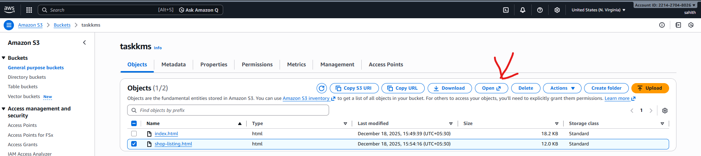
- Observed AccessDenied error in browser.
- Noted error code kms:Decrypt.
- Confirmed access denied due to missing KMS decrypt permission.
- Verified error references AWS KMS key ARN used for bucket encryption
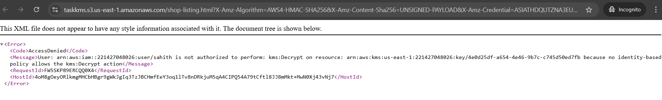
Conclusion:
- Successfully created a customer-managed KMS key for encryption.
- Configured an Amazon S3 bucket with SSE-KMS encryption.
- Uploaded objects that are automatically encrypted using the KMS key.
- Validated IAM user access and observed Access Denied (kms:Decrypt) error when KMS permissions were missing.
- Gained practical understanding of how S3, IAM, and KMS integrate to enforce secure access control.
- This task demonstrates secure data protection and highlights the importance of proper KMS permissions for accessing encrypted data.

Task Title:
Secure Database Credential Management Using AWS Secrets Manager and AWS CLI
Objective:
- To securely store and manage sensitive credentials using AWS Secrets Manager.
- To create secrets using both the AWS Management Console and AWS CLI.
- To configure AWS CLI with proper credentials and region settings.
- To validate region consistency between AWS CLI and AWS Console.
- To understand best practices for secure secret storage and access in AWS.
Prerequisites:
- Active AWS account
- AWS IAM user with permissions for:
  - AWS Secrets Manager
  - AWS CLI access
- AWS CLI installed on the local system
- AWS Access Key ID and Secret Access Key
- Basic knowledge of:
  - AWS CLI commands
  - AWS regions
  - JSON format for secret values
- Internet access and terminal (Git Bash)
Steps Performed
RDS Database Creation with Secrets Manager
- Navigated to Amazon RDS → Databases → Create database.
- Selected Easy create as the database creation method.
- Chose Engine type: MariaDB.
- Selected Free tier DB instance size.
- Entered DB identifier: taskdatabase.
- Entered Master username: admin.
- Selected Credentials managed in AWS Secrets Manager.
- Kept Encryption key: aws/secretsmanager (default).
- Skipped Set up EC2 connection.
- Clicked Create database.
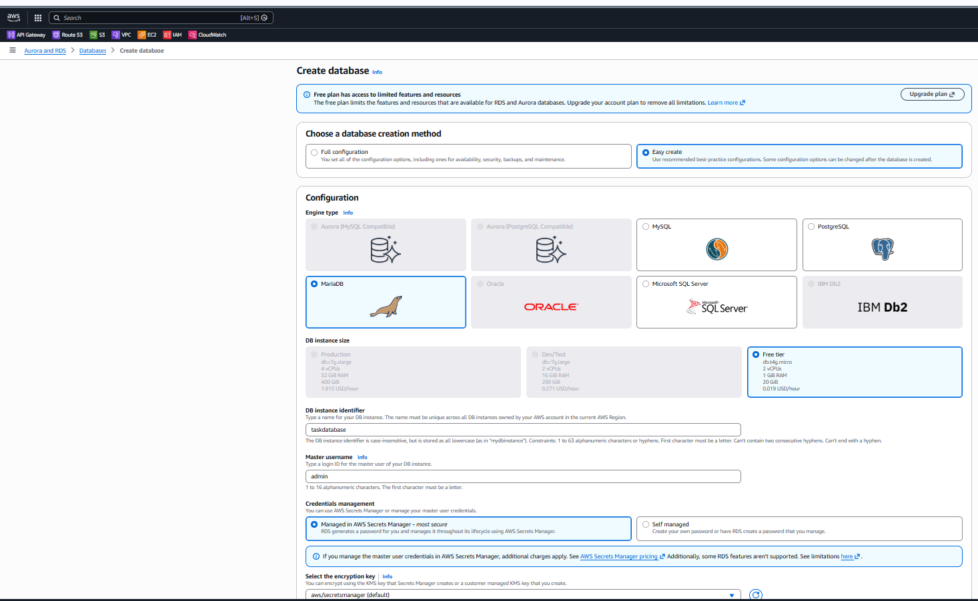
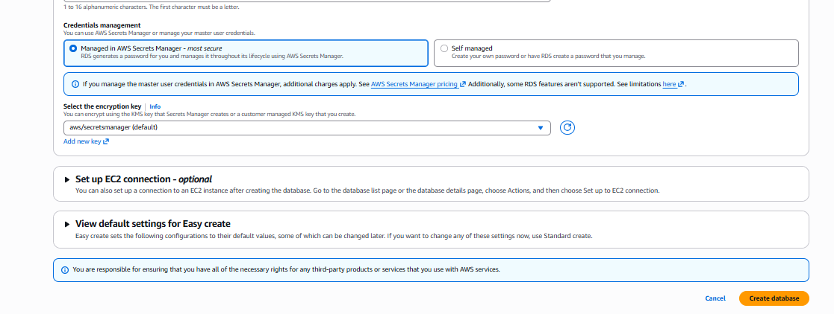
RDS Database Verification
- Navigated to Amazon RDS → Databases.
- Verified database taskdatabase is listed.
- Confirmed Status: Available.
- Verified Engine: MariaDB.
- Database has been created successfully
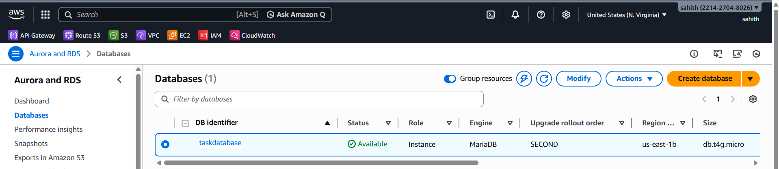
Secrets Manager – RDS Secret Verification
- Navigated to AWS Secrets Manager → Secrets.
- Verified secret automatically created by RDS.
- Opened secret rds! db-.
- Confirmed secret is managed by Amazon RDS.
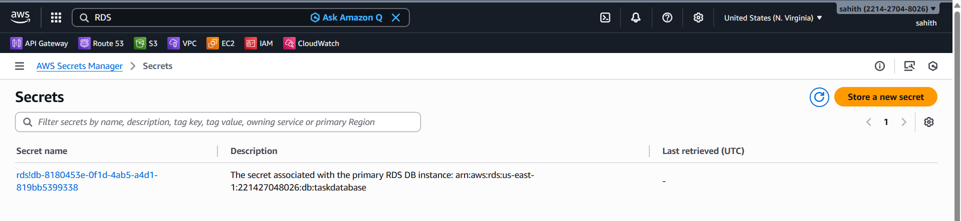
- Viewed Secret value in Key/value format.
- Verified username and password are stored.
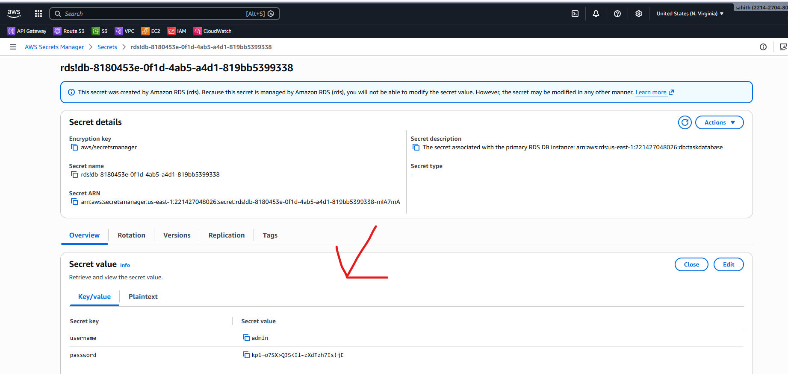
Enable Secret Rotation for RDS
- Opened Rotation tab for the RDS secret.
- Clicked Edit rotation.
- Enabled Automatic rotation.
- Set rotation schedule to every 9 days.
- Enabled Rotate immediately when the secret is stored.
- Verified Amazon RDS manages rotation.
- Saved rotation configuration.
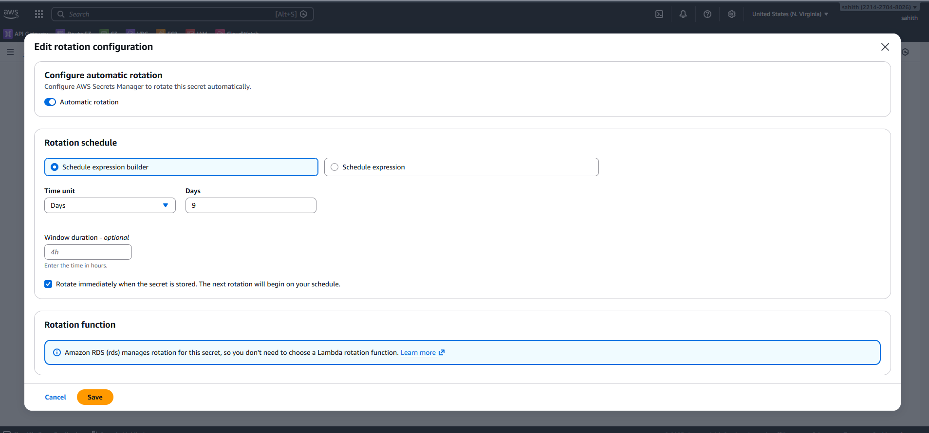
- Verified Rotation status: Enabled.
- Checked Last rotation date.
- Checked Next rotation date.
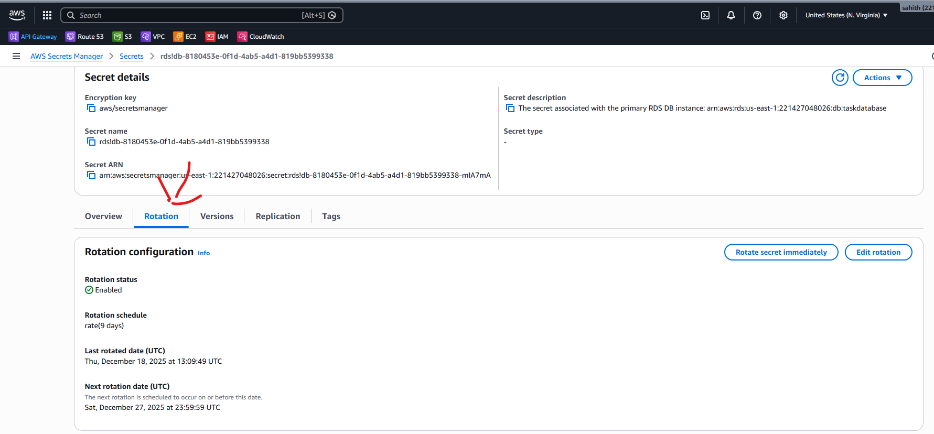
Create Custom Secret in Secrets Manager
- Navigated to AWS Secrets Manager → Store a new secret.
- Selected Other type of secret.
- Added Key/value pair:
  - Key: sahith
  - Value: Devops0509
- Kept Encryption key: aws/secretsmanager.
- Clicked Next.
- Entered Secret name: sahith/krishna.
- Added description.
- Skipped tags.
- Skipped resource permissions.
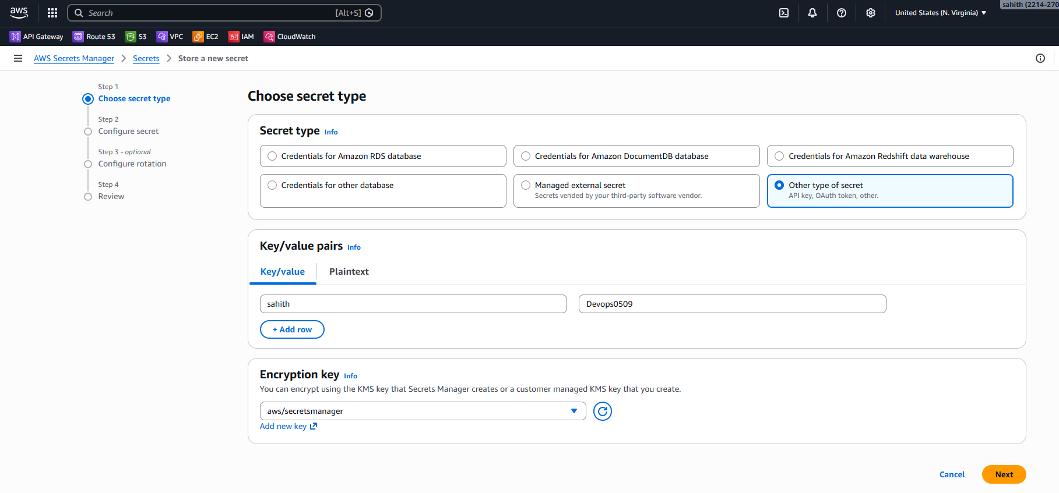

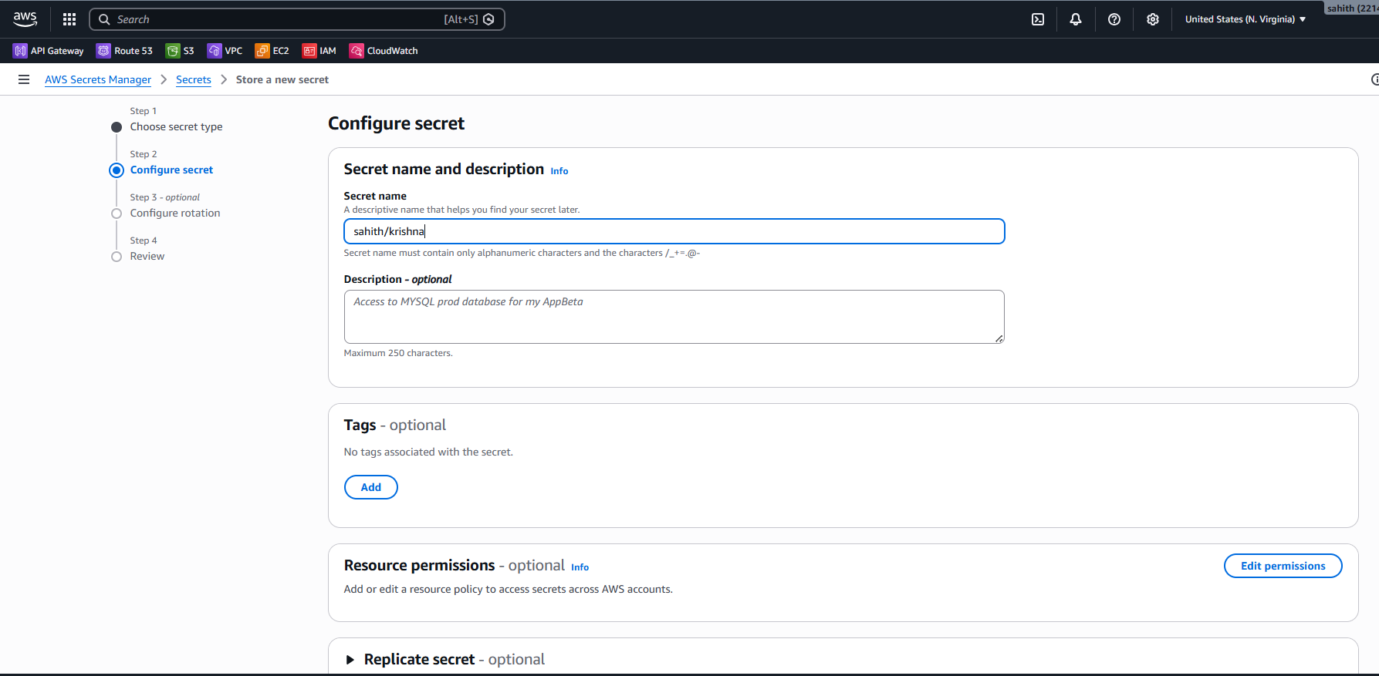
- Reviewed configuration.
- Stored the secret successfully.
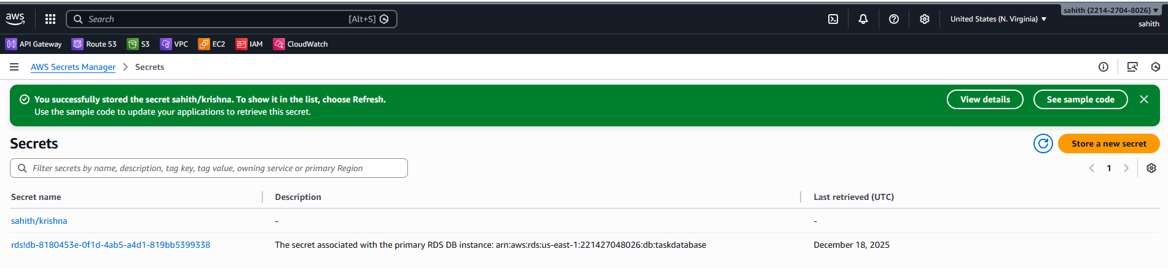
Final Verification
- Navigated to AWS Secrets Manager → Secrets.
- Verified sahith/Krishna secret appears in the list.
- Verified RDS secret and custom secret are both present.
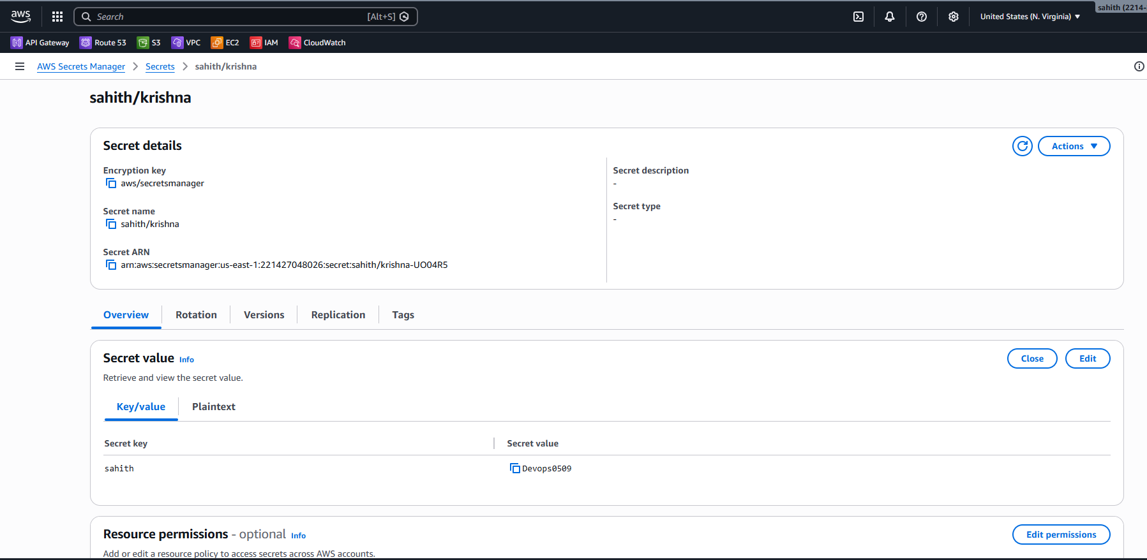
AWS CLI Configuration
- Opened terminal (Git Bash).
- Executed aws configure.
- Entered AWS Access Key ID.
- Entered AWS Secret Access Key.
- Set Default region name: eu-north-1.
- Kept Default output format: json.
Verify AWS CLI Configuration
- Executed aws s3 ls.
- Verified S3 buckets are listed successfully.
- Confirmed AWS CLI is authenticated and working.
Create Secret Using AWS CLI
- Executed AWS Secrets Manager create secret command:
- Verified secret creation response.
- Confirmed Secret ARN is generated.
- Confirmed Secret name: my-db-secret.
- Confirmed VersionId is created.
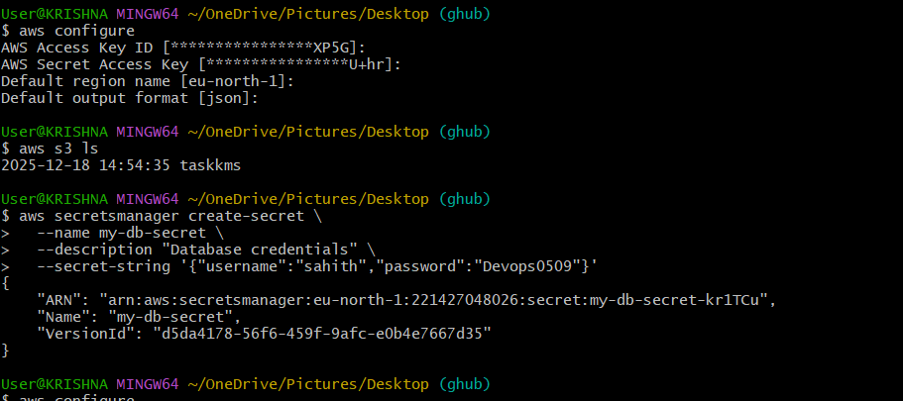
Secrets Manager Console Verification
- Navigated to AWS Secrets Manager → Secrets.
- Verified my-db-secret appears in the secrets list.
- Verified secret description as Database credentials.
- Verified secret creation timestamp.
Region Consistency Validation
- Verified AWS CLI region is set to eu-north-1.
- Verified Secrets Manager console region is Europe (Stockholm – eu-north-1).
- Ensured CLI region and console region are the same.
- Confirmed secrets created via CLI appear only in the same AWS region.
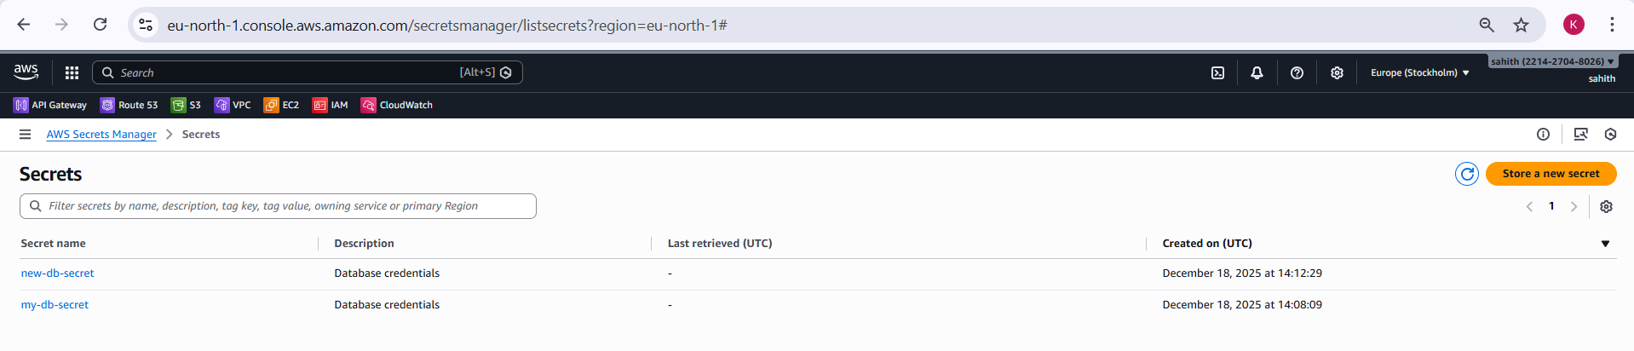
Validation Steps:
- Verified AWS CLI configuration using aws configure.
- Confirmed default region is set to eu-north-1.
- Validated CLI access using aws s3 ls.
- Confirmed secret creation output shows ARN, Name, and VersionId.
- Verified secret appears in AWS Secrets Manager console.
- Confirmed secret description and creation time.
- Ensured CLI region and Console region are the same.
- Verified no cross-region visibility issues for secrets.
Conclusion:
- Successfully configured AWS CLI with valid credentials and region.
- Created secrets securely using AWS Secrets Manager via AWS CLI.
- Verified secrets through the AWS Management Console.
- Ensured region consistency between CLI and Console to avoid access issues.
- Gained hands-on experience in secure credential management using AWS Secrets Manager.
- This task demonstrates secure handling of sensitive information and adherence to AWS best practices.

Overall Task Conclusion:
- Successfully implemented end-to-end security for data and credentials in AWS.
- Configured customer-managed KMS keys and applied them to Amazon S3 encryption.
- Validated how IAM and KMS permissions affect access to encrypted resources.
- Created an RDS database with credentials managed securely in AWS Secrets Manager.
- Enabled automatic secret rotation for enhanced security.
- Created and managed secrets using both AWS Console and AWS CLI.
- Ensured region consistency between CLI and Console to avoid access issues.
- Gained practical, real-world understanding of AWS encryption, access control, and secret management following AWS best practices.

